Prof N.P.Tiwary For Students of B.sc, Part I, Paper I.
Co-ordinator Zoology
N.O.U, Patna
Topic
Describe the structure and life history of Sacculina.
Sacculia Structure and lifecycle
Systematic Position:
Phylum – Arthropoda
Subclass – Cirripedia
Order – Rhizocephala
Genus – Sacculina
Life History of Sacculina.
Sacculina lives as a parasite on crab and is commonly known as root-headed barnacle The parasitic habit has caused much degeneration of different structures in the adult. The crab that most often is used as a host is the green crab, the natural range of which is the coasts of Western Europe and North Africa
In adult the different structures like mouth and anus are absent. It is like a soft round tumour on the abdomen of the crab. From this tumour numerous branched filaments ramify in all the parts of the body of the host except the heart and the gills

The adult Sacculina (Sacculina externa) is characterised by:
1. Loss of segmentation and appendages.
2. All the organ systems are degenerated except the reproductive organs.
3. There is a pair of elongated testes and a pair of ovaries with accessory genital glands, genital atrium and collaterial glands.
4. There is a single nerve ganglion.
5. Sacculina is hermaphrodite.
6. An adult female produces numerous eggs.
7. The mechanism of fertilization is not actually known.
8. There are diverse opinions regarding the process of fertilization. Fertilization in Sacculina, in all probabilities, is internal.
9. A degenerated adult female lays eggs in bunches with the help of cementing glands which provides a cuticular covering. The two batches of the eggs are attached in the broad chamber through a minute hood like elevation called retinacula. These retinacula are internal elevations of the brood chamber. The young ones are hatched from the egg as a free-swimming Nauplius larva
The adult Sacculina is difficult to recognise as an arthropod. The study of its developmental history justifies its inclusion as a crustacean.
Nauplius larva:
- The young are hatched from the eggs as free-swimming Nauplius larvae.
- The nauplius larva is more or less triangular in shape
- Presence of two front lateral horns, each containing a pair of gland cells.
- It has a median eye
- Presence of three pairs of appendages for swimming.
- The second and third appendages are devoid of any masticating process.
- The body terminates posteriorly into caudal furca. The mouth and alimentary canal are absent in the nauplius and it contains numerous germ cells (ova).
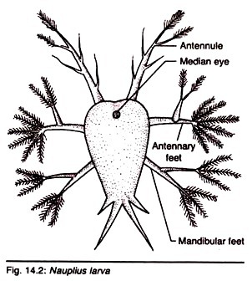
II. Cypris larva:
- The nauplius transforms into a Cypris stage after 3 or 4 months.
- The free-swimming cypris bears a bivalved shell, six pairs of thoracic biramous appendages and numerous germs cells.
- The abdomen is extremely reduced and is without any appendage.
- The abdomen is terminated in a pair of caudal rami.
- Single eye persists.
- A pair of front-lateral glands opens near the margin of the valves of the shell.
- A pair of three-segmented antennules is present.
- The terminal segment of the antennule bears backwardly curved structure—the organ for attachment.
- After a period of free swimming life, the cypris larva attaches itself to the body of the crab by the help of its hook-like antennule.
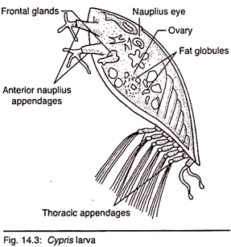

III. Kentrogen larva:
- The cypris discards its thoracic appendages with muscles along with the bivalved shell.
- The contents of the anterior region of the body become detached and are enclosed in a new sac remaining in connection with the antennules which are fixed to the host.
- The old cuticle is replaced by a new one to enclose the rest of the body like a sac.
- The body consists merely of a ball of cells.
- The pointed end of the cuticle of parasite’s hook begins to bore the cuticle of the crab.
- It is then known as Kentrogen stage.
- Within it a chitinous rod known as dart is differentiated.
- The point of the dart lies within the fixed antennule. When it is fully formed, it forces its way through the cuticle of the host.
- Through this dart, the contents of the sac consisting of a mass of undifferentiated cells surrounded by an ectodermal layer pass into the body cavity of the crab.
- The cells of the parasite enter within the body of the crab and are carried by the blood stream into the thoracic cavity.
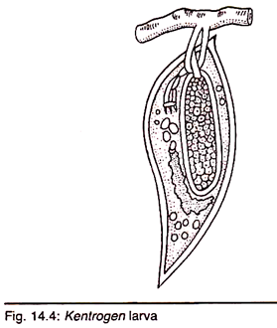
IV. Sacculina interma:
- There the cells of the parasite multiply leading into a stage called Sacculina interna.
- It then sends slender processes throughout the body of the crab to draw nutrition.
- The main body of the Sacculina interna, as it continues to grow, degenerates the tissues of the host’s body wall.
- Finally the main body of the parasite pushes out as a swelling in the abdomen of the crab.
- This phase is called the Sacculina externa.
Duration of Life Cycle of Sacculina:
According to Delage (1884), Sacculina becomes external at the age of 20-22 months. The total life of parasite is about 3 years. If the host is fresh-water crab, the life cycle is somewhat changed. The nauplius stage of the parasite is deleted and the eggs give rise to cypris stage directly.
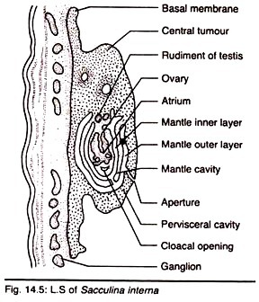
Retrogressive Metamorphosis:
The adult Sacculina does not bear any arthropodian characters. But the larval forms are well-developed and they possess many arthropodian features. During metamorphosis, the larva loses all the arthropodan characters and becomes the degenerate adult. Such a type of metamorphosis is called ret­rogressive metamorphosis.
Effects of Parasitism on Sacculina:
The parasitic mode of life exerts tremendous effects on the parasite as well as on the host
On the host:
1. The host crab shows great disturbance in the metabolic processes.
2. The process of moulting ceases when the parasite becomes external.
3. In both the sexes of the crab, the infection of sacculina inhibits reproductive activities resulting into the atrophy of gonads, called parasitic castration.
4. Smith (1906) opined that its destruction takes place through autodigestion.
5. The males, in addition, lose distinctive male features, i.e., shapes of the chelate legs.
6. They develop various degrees of secondary sexual characters proper to the females.
7. The chelipeds remain in the form of non-breeding phase.
8. The abdomen becomes more or less flattened and may assume the female form.
9. The copulatory styles are greatly reduced and small pleopods may appear on the third to fifth abdominal pleopods.
10. It has also been reported that a completely modified male, when recovers from the parasitic infection, may be able to regenerate gonads in some cases.
11. Thus the individual becomes hermaphroditic producing both ova and sperms.
2. The female crab, after infection with Sacculina, shows great reduction in the size of the pleopods and the gonads
On the parasite:
Most of the organs lead to a high degeneration excepting the genital organs and the organ for adhesion.
Impact of Parasitic Life on Crustacean:
It is evident from the above-mentioned examples of parasitic crustaceans that para­sitism often involves following changes in the parasites themselves:
1. Loss of segmentation.
2. Loss of appendages.
3. Loss of different systems, i.e., alimen­tary, circulatory and excretory systems.
4. Loss of typical crustacean features and
5. Reduction of metabolic rate.
The effects of parasitism increase with the degree of parasitic life. The endoparasites exhibit more degenerative changes than the ectoparasites. In some, like Sacculina, the degeneration is so extreme that only through the study of their larval forms it has been possible to ascertain their systematic posi­tion.
In spite of these degenerative changes the parasitic crustaceans exhibit suitable mechanisms for holding and piercing the host, for absorbing nutrients and possess efficient reproductive mechanism to help in prolific multiplication and safe dispersal. Thus parasitism not only causes degeneracy but also leads to specialisation. Both are needed for the survival of the individual.

