COURSE : DISASTER MANAGEMENT (MA/ MSc PART I)
Paper : IV
Prepared by : Prof. B. K. Mishra, Course coordinator
Topic : GIS & its applications

INTRODUCTION
A geographic information system (GIS) is a system designed to capture, analyze, store, manipulate, present and manage all types of geographical data, like information from maps, global positioning systems (GPS) and ubiquitous data, like locations of landmarks and areas hit by calamities. It can display data related to positions on the Earth's surface and show these different types of data on a map, allowing people to see various data patterns and relationships.
The primary benefit of a GIS is its cross-discipline communication. Because people have the ability to understand visual impulses, this enables better communication. A GIS also facilitates better decision making. For example, it is easier for a disaster response coordinator to manage and shift resources when a field can be visualized to determine which areas are in need of help, as well as the urgency and capacity of that help.
Google Maps is the best example of a GIS.
GIS can refer to a number of different technologies, processes, techniques and methods. It is attached to many operations and has many applications related to engineering, planning, management, transport/logistics, insurance, telecommunications, and business. For that reason, GIS and location intelligence applications can be the foundation for many location-enabled services that rely on analysis and visualization.
GIS can relate unrelated information by using location as the key index variable. Locations or extents in the Earth space–time may be recorded as dates/times of occurrence, and x, y, and z coordinates representing, longitude, latitude, and elevation, respectively. All Earth-based spatial–temporal location and extent references should be relatable to one another and ultimately to a "real" physical location or extent. This key characteristic of GIS has begun to open new avenues of scientific inquiry.
COMPONENTS of GIS
Geographic Information System has five of the following components:
Hardware.
Software,
Data,
People, and
Methods.

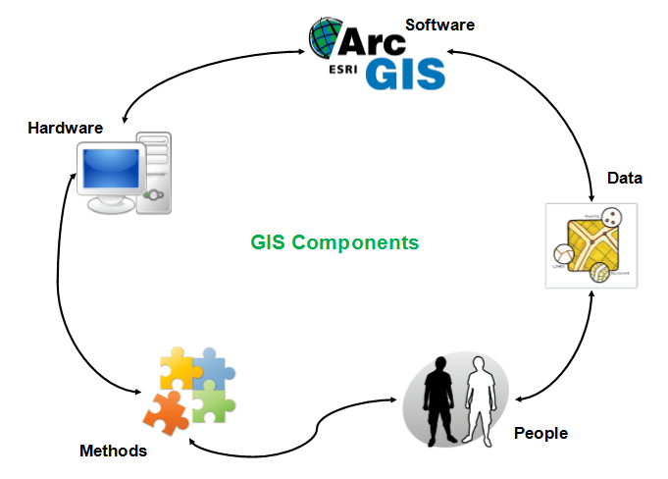
Hardware: Hardware is Computer on which GIS software runs. Nowadays there are a different range of computer, it might be Desktop or server based. ArcGIS Server is server based computer where GIS software runs on network computer or cloud based. For computer to perform well all hardware component must have high capacity. Some of the hardware components are: Motherboard, Hard driver, processor, graphics card, printer and so on. These all component function together to run a GIS software smoothly.
Main Hardware Components:
- Motherboard: It is board where major hardware parts are installed or It is a place where all components gets hooked up.
- Hard Drive: It is also called hard disk, place to store data.
- Processor: Processor is the major component in computer, it performs calculation. It is called as Central processing Unit (CPU).
- RAM: Random Access Memory (RAM) where all running programs load temporarily.
- Printer: It is output device and used to print image, map or document. There arevarious type of printer available in market.
- External Disk: These are portable storage space such as USB drive, DVD, CD or external disk.
- Monitor: It is a screen for displaying output information. Nowadays there are various type of monitor: CRT (cathode ray tube), LCD (Liquid Crystal Display), LED (Light Emitting Diodes) and more.
Software: Next component is GIS software which provide tools to run and edit spatial information. It helps to query, edit, run and display GIS data. It uses RDBMS (Relational Database Management System) to store the data. Few GIS software list: ArcGis, ArcView 3.2, QGIS, SAGA GIS.
Software Components:
- GIS Tools: Key tools to support the browsing of the GIS data
- RDBMS: Relational Database Management System to store GIS data. GIS Softwareretrieve from RDBMS or insert data into RDBMS.
- Query Tools: Tools that work with database management system for querying, insertion, deletion and other SQL (Standard Query Language).
- GUI: Graphical User Interface that helps user and Software to interact well.
- Layout: Good layout window to design map.
Data: The most important and expensive component of the Geographic Information System is Data which is generally known as fuel for GIS. GIS data is combination of graphic and tabular data. Graphic can be vector or raster. Both type of data can be created in house using GIS software or can be purchased. The process of creating the GIS data from the analog data or paper format is called digitization. Digitization process involves registering of raster image using few GCP (ground control point) or known coordinates. This process is widely known as rubber sheeting or georeferencing. Polygon, lines and points are created by digitizing raster image. Raster image itself can be registered with coordinates which is widely known as rectifying the image. Registered image are mostly exported in TIFF format. As mentioned above, GIS data can be Raster or Vector.

