Lesson by Prof. A. K. Nag, professor and Head, Department of Chemistry College Of Commerce, Arts and Science, Patna, for Nalanda Open University, Chemistry M.Sc. part-I , Paper-VIII.

METAL COMPLEXES IN TRANSMISSION OF ENERGY
Metal complexes (Coordination compounds) are closely related to life process; however the proper understanding of the coordination aspects of biochemical processes is limited due to the complex structures of the biochemical molecules. Eichorn underlined the participation of coordination compounds in almost every phase of biological activity. All these processes involve one or more enzymes, which need metallic ions for their activity and 156 have been shown to function as metal complexes e.g. in the natural process of bond formation and bond rupture (cleavage of peptide bonds or carboxylation and decarboxylation reaction, or phosphorylation reaction i.e. conversion of ATP to ADP etc); the exchange or blocking of functional groups; in influencing stereo-chemical configuration; in oxidation-reduction reaction; in storage and transfer reactions (transportation of oxygen i.e. functioning of haemoglobin) and in transmission of energy. For transmission of energy functioning of chlorophyll (Mg²⁺complex) during photosynthesis is an important example. Chlorophyll:
Chlorophyll is the best known and highly special coordination compound of plants, which takes photons from sunlight and pass it to the system responsible for conversion into necessary energy for the chemical change. Like haemoglobin, chlorophyll is also a metal-porphyrin complex, in which Mg (II) ion remains coordinated with the four nitrogen atoms of porphyrinring stated in a square planer geometry
Chlorophyll is a green pigment of plants, which plays important part in photosynthesis process.
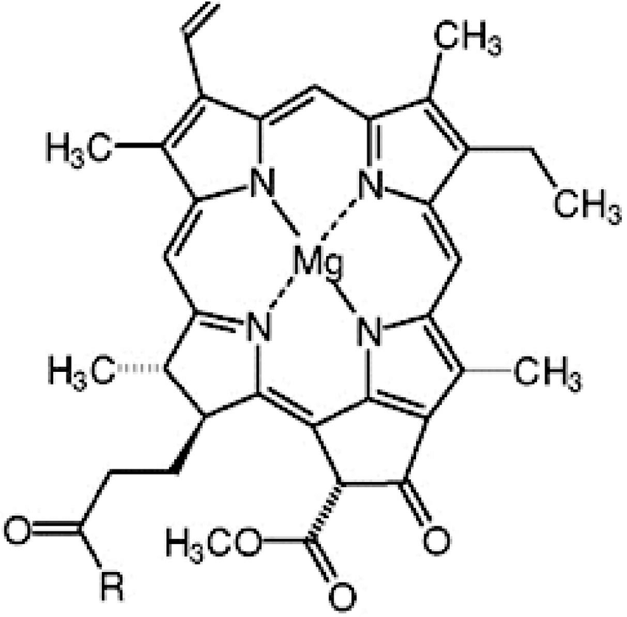
Fig. 3.5: Chlorophyll

A double bond of a pyrrole ring in chlorophyll is reduced and the long alkyl chain at the base of its structure is a phytyl group.
A reason for usefulness of chlorophyll in photosynthesis process is high conjugation of porphyrin ring. This reduces the energy of electronic transfers and shifts the absorption centre in 350-700 nm region, where one or more photosynthetic pigments absorb light at every frequency. The main point of the reaction centre is a pair of chlorophyll molecules, called special pair. In the special pair, one pyrrole ring of each molecule remains in contact with the other by overlapping.
In addition to this on each molecule an acetyl group remains coordinated with magnesium atom of other molecule. On the sixth coordination site of each magnesium atom, nitrogen of histidine part of the protein chain is attached. Special pair also remains attached with pheophytin and quinone molecule, which accept electron from the reaction centre.
Near the quinone molecule is present one non-home iron atom, which remains coordinated with four histadine and one ghetamic acid. Electron reach in to the reduction chain through the iron atom. The hole (the centre where electron is absent) of the reaction centre is filled with the electron obtained from cytochrome. The separation of charge between positive charge on Fe(III)-cyto chrome and the electron coming in z-scheme chain represents the potential energy used in photosynthesis - process.

Photosynthesis:
Photosynthesis converts radiant energy into useful, high quality chemical energy in the bonds that holds together organic molecules. Energy captured by photosynthesis supports nearly all life on earth. During photosynthesis, solar energy is converted into chemical energy, when atmospheric CO₂ is assimilated during the synthesis of organic molecules. During this process, water provides the reducing power and the pigments capture the light energy. The present status of our knowledge about photosynthesis has been achieved through the use of techniques from a wide variety of disciplines including physics, bioenergetics, biophysics electron microscopy, bioenergetics, biophysical electron microscopy, biochemistry and chemistry, plant physiology, agronomy, genetics and molecular biology. In recent years, spectacular success has particularly been achieved in resolving the structure of several membrane proteins associated with the photosynthetic apparatus, so that this apparatus (mainly the type-II reaction centre in bacteria) is the first complex biological system, for which structure, function and regulation has already been described in rigorous physicochemical terms at the atomic level. Therefore, now it is a challenge for scientific community to devise low cost artificial power generating systems capable of exploiting solar energy based on the principles of photosynthesis. The equation of photosynthesis can be written as follows:

6CO₂ + 12 H₂O ⎯light ⎯⎯+→ C₆H₁₂O₆ + 6O₂ + 6H₂O

Although initially it was believed that the O₂ evolved during photosynthesis is derived from CO₂ later it was established beyond any doubt that this O₂ is actually derived from water. The reactions involved in the release of O₂ from water is described as Hill reactions after the name of Robert Hill. He was the first to demonstrate the origin of O₂ from H₂O (rather than from CO₂) during photosynthesis according to the following equation:
2H₂O ⎯light ⎯⎯+→ O₂ + 4H⁺ + 4e-

The biochemical process:
Photosynthesis may be divided into two main groups.
The first of these involves those chemical reactions necessary for the conversion of the radiant energy of the sun into the chemical energy of compounds which plant cells are able to use as energy sources for the synthesis of organic compounds. These reactions are appropriately known as the light reactions.
The second division of the field of photosynthesis includes the reactions by which the chemical energy of each of the compounds formed in the light reactions is utilized to promote the formation of organic substances from inorganic materials. These processes are termed the dark reactions.
- Light reaction (electron transport and generation of NADPH and ATP) for this reaction, light is necessary. In higher plants, it takes place in grana and stoma lamellae of the thylacoid membrane of the chloroplast.
In photosynthetic bacteria having no chloroplasts, this reaction take place in the cell membrane containing the pigment system. This involves oxidation of water, leading to the transfer of electrons to NADP+ and to the ultimate production of NADPH and ATP. This light reaction takes place in proteinpigment complexes described as reaction centres. In photosynthetic bacteria, there is only one reaction centre, but in organisms including cyanobacteria, algae and higher plants there are two reaction centres.
- Dark reaction (carbon dioxide reduction in C₃, C₄ and CAM plants). In this reaction, light is not necessary, but it can take place in the light as well. This reactions takes place in the stroma and makes use of NADPH as the reducing power and ATP as the source of energy for reduction of atmospheric CO₂ into carbohydrates. The CO₂ assimilation can take place through the synthesis of a stable compound, which is a 3 carbon compound (phosphoglyceric acid) in majority of plants but can also be a 4 carbon compound (oxaloacetate, malate or aspartate) as in several grasses and Crasulacean plants (succulents). It will be shown later that the C₄ pathway, involving the synthesis of a 4 carbon compound (malate or aspirate) as Calvin-Beason cycle, which is universally accepted. Similarly C₄ – pathway was worked out by M.D. the first stable compound, is more efficient, since it does not allow photorespiration, which is a wasteful process for C₃-pathway. Melvin Calvin and his co-workers at the University of California worked out the mechanism of the reduction of CO₂ and suggested a cyclic pathway, now described as Hatch and C.R. Slack in 1970 and is described as Hatch and Slack Pathway. Metabolic pathway for CO₂ fixation in CAM (Gassulacean Acid Metabolism) plants, through resembles that in C4 plants, differs from it in several essential features.
The photosynthetic reactions occur in tiny, membranous organelles, the chloroplasts of plant cells. Like mitochondria, these relatively large particulate components of the cytoplasm have complex internal structures. Chlorophyll molecules are concentrated within the chloroplasts, in small bodies known as grana. Each of these appears to consist of an intricately folded lipoprotein membrane, resulting in a many-layered structure. The chlorophyll molecules are sandwiched between layers of the lipoprotein. Probably the long hydrocarbon chain of the chlorophyll molecule is associated with the lilied portion of the membrane protein, while the remainder of the molecule is linked with a water-soluble portion of the protein. Relatively large amounts of carotenoid compounds such as β- carotene and Vitamin K also occur in the grana, perhaps as part of the lipoprotein membranes.

Mechanism of Photosynthesis:
(Light-induced electron transport and generation of NADPH and ATP) we earlier described that light energy is captured during the 'light reaction' and that CO₂ is reduced during the 'dark reaction' of photosynthesis. The reduction of CO₂ leading to production of carbohydrates is the ultimate goal of photosynthesis. However, for achieving this goal, following two co-factors are needed (i) NADPH, which, in the form of a high-energy compound, works as an energy source and (ii) ATP, which in the form of high energy compound. These two co-factors (NADPH and ATP) are produced during light-induced electron transport, taking place, in the thylakoid membrane of the chloroplasts in algae and higher plants.
The process of energy conversion in photosynthesis begins, when light is absorbed by chlorophyll molecule locked in the light harvesting complex. The chlorophyll molecule gets excited by a quantum of light (photon); this involves movement of an electron from a molecular orbital of lower energy level to another orbital of higher energy level. Such an excited chlorophyll molecule is unstable and will tend to return to its original unexcited stale in one of the following three ways :
- extra energy is converted either exclusively to heat energy (used in movement of molecules) or to a combination of heat and light of long wave length (used in fluorescence); fluorescence can be seen when light is absorbed by isolated chlorophyll molecules in solution;
- extra energy (not the electron itself) is transferred to a neighbouring chlorophyll molecule by a process called resonance energy transfer and is used for increasing the energy level of an electron in this neighbouring molecule;
- the excited chlorophyll molecule takes the role of electron donor and transfers the high energy electron to a nearby molecule (not necessarily a chlorophyll). This nearby molecule performs the role of an electron acceptor. The chlorophyll molecule, excited due to absorption of a photon, after transfer of a high energy electron, now accepts a low energy electron from some other molecule (electron donor) and returns to its ground stale. The last two of these three mechanisms are utilized during photosynthesis. The first of these last two mechanisms (resonance energy transfer) is utilized for transfer of energy from one chlorophyll molecule to another in the light harvesting complex (also called antenna complex), without the transfer of electron and the second is utilized in the transfer of a high energy electron from excited singlet state: (PD) of chlorophyll in 'special pair' to the primary electron acceptor (PA). In a simplified version, we may say during photosynthesis, after decomposition of water into component elements, carbon dioxide is reduced:

2H₂O → 4[H] + O₂ x CO₂ + x/2 [4H] → [CH₂O]x + x/2 O₂

In green plants there are two paired photosynthesis systems A and B. Both differ in the type of chlorophyll present and in the chemical using the absorbed photon energy (the ratio of chlorophyll A and B is 3:1). Chlorophylls absorb lower energy light (~700 nm) in far i.r. region. When photon colloids with chlorophyll of any system (A or B) it provides energy for the series of redox reactions.
- I st Step : Chlorophyll excitation :
hυ
Chl ⎯⎯hV -----→ Chl*
Chlorophyll

2. IInd Step : Within picoseconds energy transfers in to electrophile
Chl* ⎯→ Chl⁺ + A₃.

Next Step : Excited acceptor transfers energy to other acceptor and this follows:
A ⁻ + B ⎯→ B ⁻ + A B ⁻ + C ⎯→ C ⁻ + B

After many steps:
6CO₂ + 6 H₂O ⎯→ C₆H₁₂O₆ + 6O₂
These redox reactions take place in a series.

Photosystems I and II
In higher plants and in cyanobacteria photochemical reaction centre and the light harvesting complex(es) (also called antenna complex) associated with it together form a photosystem. There are two such photosystems, photosystem II (PSII) and photosystem I (PSI) embeded in the thylacoid membrane and linked with each other through a thermochemical bridge consisting of several electron carriers, particularly the mobile plastoquinone (PQ) and plastocyanin (PC). The present status of our knowledge about the structure and organization of these components both in higher plants (also in algac and cyanobacteria) and in photosynthetic bacteria will be briefly presented here.
Photosynthetic organisms have two tasks in early steps of photosynthesis : (i) to capture photons with high efficiency and at a reasonable metabolic cost and transfer them to a reaction centre and (ii) to convert solar energy into chemical energy. The photosystem II (PSI1) and photosystem I (PSI), mentioned above, are multiprotein complexes. They respectively contain, type-II and type-I reaction centres (also called trapping centres) along with their light harvesting complexes (LHCII and LHCI). These reaction centres are comparable to the corresponding reaction centres of photosynlhetic bacteria, particularly for the purpose of relating them with their evolutionary origin.
These two reaction centres, in terms of their chemical constitution, are 'pigment-protein complexes' and are distinguished from each other due to their different terminal electron acceptors. Type-I reaction centre, found in green sulphur bacteria and heliobacteria, are characterized by having low 165 potential iron-sulphur centres as terminal electron acceptors. Type-II reaction centre, found in anaerobic sulphur and non-sulphur purple bacteria (e.g. Rhodopseudomonas viridis and Rhodobactsr sphaeroides) and also in some green bacteria (e.g. Chloroflexus), on the other hand, are characterized by having quinines as their terminal electron acceptors. As we know, in higher plants the two reaction centres arc coupled together in series, through a thermochemical bridge (which does not need light) so as to oxidize water and create a low redox potential needed to reduce NADP⁺ . Reduced NADP⁺ (NADPH), with ATP arc then used to convert CO2 to organic molecules (this involves addition of CO₂ to RuBP, a 5-carbon compound, to produce 6-carbon compound like glucose).
In higher plants, besides PSII and PSI, there are following two other membrane complexes involved in the production of NADPH and ATP : (i) cytochromc b₆f, which acts as a redox link between PSII and PSI and (ii) coupling factors (CF0 and CF1), which arc components of ATP synthase complex and are involved in the production of ATP from ADP, through the use of transmembrane proton gradient generated by light driven electron transfer from PSII to PSI (in accordance with Milchcll's, 'chemiosmotic theory').
Both the above functions are, however, done by the pigment systems, present in the plasma membranes in bacteria and in the thylacoid membrane of the chloroplasts in algae and higher plants. In chloroplasts of higher plants, there are about 60 different proteins (only half of them coded by cpDNA), associated with the energy converting systems, but only about a dozen of them are directly involved in the energy transduction pathways. The pigment molecules responsible for collection of energy (ultimately for extracting electrons from a substrate, to be transferred to an electron 166 acceptor) are a part of the light harvesting complexes designated as LH1 and LH2 for bacteria and LHCI and LHCII for higher plants.

Photosystem-I :
(Type-I reaction centres) The type-I reaction centre resembles type-II reaction centre in many ways and is found in isolation in some an-oxygenic organisms including green-sulphur bacteria and heliobacteria. In association with type-II reaction centre (found in PSII), this reaction centre (type-I RC found in PSI) is also found in oxygenic photosynthetic organisms including cyanobacieria, algae and higher plants, where aerobic photosynthesis is carried out following the Z-scheme. Like type-II reaction centre, in type-1 reaction centre also, a 'special pair' of chlorophylls acts as the primary electron donor. The oxidizing potential generated in type-I reaction centre is the same (about +0.4V) in oxygenic and anoxygenic organism, in contrast to type-Il reaction centre, where it differs in oxygentic (+1.1V) and anoxygcnic organisms (+ 0.4V).
The type-I reaction centre is also a protein-pigment complex and has a two-fold symmetry like type-II reaction centre, although its structure at the atomic level has not been resolved, to the same level as that of type-II reaction centres. However, in type-I reaction centre also, there are two similar or identical proteins, which form dimmer. It differs from the protein dimmer of type-II reaction centre, in having a large number of lightharvesting chlorophylls. The low-potential (0.7V) of 4 Fe-4S (terminal electron acceptor) reduces NAD⁺ or NADP⁺ through other iron-sulphur centres, which are located in proteins associated with the outer surface of the reaction centre dimer.
In oxygenic photosynthetic organisms (cyanobacteria, algae and higher plants), PSI consists of a number of intrinsic polypeptides and extrinsic polypeptides, which include ferredoxin containing Fe₂S₂ centers and ferredoxin-NADP reductase (flavoprotcin). The most important of these is 68kD protein, which is a tetramer and contains P-700. It binds about 13 'chlorophyll a' and 6 caratenoid molecules. The AO and A1 acceptors arc also present on this polypeptidc. Associated with four polypeptides in PSI complex in chloroplasts, there is also a light harvesting complex I(LHCI), whose polypeptides range from 22 kD to 25 kD .

Photosystem-II :
(Type-II reaction centres). The type-II reaction centre is exemplified by the reaction centre found in photosynthetic purple bacteria, Rhodopseudomonas viridis and Rhodobacter sphaeroides. In these bacteria, the three dimensional structure of type-II reaction centre has been studied in great detail, leading to the award of 1988 Nobel Prize in Chemistry to J. Deisenhofer, R. Huber and H. Michel of Max Planck Institute in Martinsried, Germany.
In higher plants PS II complex of
- water-splitting or oxygen evolving complex (OEC),
- PSII core complex (reaction centre) and
- LHCUII. Four proteins of oxygen evolving system,
12 polypeptides belonging to the core complex and five proteins belonging to the LHCII are known. While proteins for oxygen evolving complex and LHCII are encoded in the nucleus, those for
PS Il core complex are encoded in the chloroplast genome. Many of these proteins are integral membrane-spanning polypeptides, but some of them are extrinsic polypeptides. The extrinsic polypeptides can be removed by relatively simple procedures (washing with salt solutions under appropriate pH conditions).
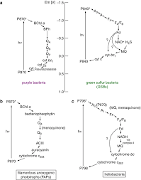

Thus in photosystem-I, the common strong reducing specie, REDA and the strong oxidising species, OXA are formed, while in photosystem-II

Photosynthesis System B Phtosynthesis System A .
Electron movement in photosynthesis system A and B a strong oxidising agent, OXB but a weak reducing agent, REDB are obtained. The function of OXB is to produce molecular oxygen. A manganese complex, reduce OXB, which is regenerated, by an another excited chlorophyll molecule, for further use. In this redox reaction manganese is converted into +2, +3 and +4 states.
REDA gives its electron to a carrier like ferredoxin [Fe²⁺/Fe³⁺], as a result NADPH is formed which is a stable source for reduction of carbon dioxide into carbohydrate.
In photosystem-II (Photochemical system B) the carrier is pheophytin. The ion pair formed in step 1 st (given above) are Chl⁺ and Pheo- .
Here two points are important:
- The excessive conjugation of porphyry system, which is responsible for the shift of absorption in the visible reason, also increases the strength of the ring and saves the loss of energy due to molecular vibrations, and
- The phosphorescent behaviour of chlorophyll for phosphorescence presence of a metal ion is necessary. Free porphyrin gives only fluorescent emission. Metal ion helps in mixing of excited singlet and trilpet states, thus promotes formatron of relatively stable triplet state, which is the source of energy for phophorescence and photosynthesis.

xxxxxxxxxxxxxxxxxxxxxxx---------xxxxxxxxxx-------xxxxxxxxxxxx

