E-content prepared by Dr. Arvind Kumar Nag¹ and Dr. K. K. Singh²

1. Professor and Head, Department of Chemistry, College of Commerce, Arts and Science, Patna.

2. Principal Coordinator, Chemistry, Nalanda Open University, Patna

Q. What do you mean by the term alternant and non-alternant hydrocarbons? Explain your answer with suitable examples.

Answer: Alternant and Non-alternant Hydrocarbons
Aromatic hydrocarbons can be divided into alternant and non-alternant hydrocarbons. In alternant hydrocarbons, the conjugated carbon atoms can be divided into two sets such that no two atoms of the same set are directly linked. For example, one set may be seen below for understanding. Naphthalene is an alternant and azulene a non-alternant hydrocarbon:
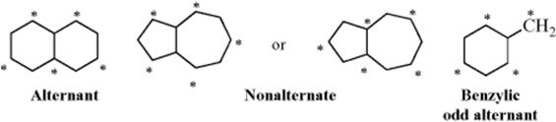
In alternant hydrocarbons, the bonding and anti-bonding orbitals occur in pairs; that is, for every bonding orbital with say, energy –E there is an anti-bonding one with energy +E (Fig.1). Even-alternant hydrocarbons are those with an even number of conjugated atoms, that is, an equal number of starred and unstarred atoms. For these hydrocarbons all the bonding orbitals are filled and the electrons are uniformly spread over the unsaturated atoms.
Fig.1. Energy levels in odd- and even-alternant hydrocarbons. The arrows represent electrons. The orbitals are shown as having different energies, but some may be degenerate.
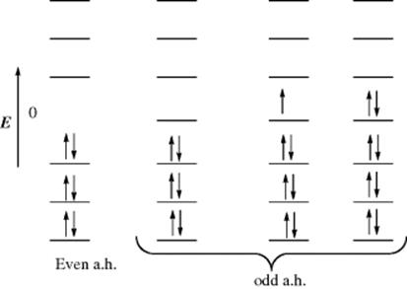

As with the allylic system, odd-alternant hydrocarbons (which must be carbocations, carbanions, or radicals) in addition to equal and opposite bonding and antibonding orbitals also have a nonbonding orbital of zero energy. When an odd number of orbitals overlap, an odd number is created. Since orbitals of alternant hydrocarbons occur in −E and +E pairs, one orbital can have no partner and must therefore have zero-bonding energy. For example, in the benzylic system the cation has an unoccupied nonbonding orbital, the free radical has one electron there and the carbanion has two (Fig. 2). As with the allylic system, all three species have the same bonding energy. The charge distribution (or unpaired-electron distribution) over the entire molecule is also the same for the three species and can be calculated by a relatively simple process.²⁰⁸
Fig. 2. Energy levels for the benzyl cation, free radical, and carbanion. Since α is the energy of a p orbital (Sec. 2.B), the nonbonding orbital has no bonding energy.
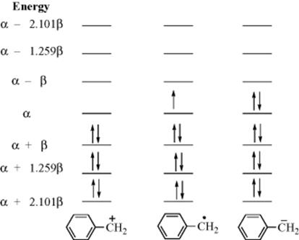
For non-alternant hydrocarbons, the energies of the bonding and anti-bonding orbitals are not equal and opposite and charge distributions are not the same in cations, anions, and radicals. Calculations are much more difficult, but have been carried out.
(Notes prepared as e- content for M.Sc. Chemistry students of 1st Part Paper VIth .Coutrsey- Advance Organic Chemistry ,by prof. Jerry March)
﻿XXXXXXXXXXXXXXXXXXXXXXXXXXXXXXXXXXXXXXXXXXXXXXXXX
﻿

